General Instructions
When attaching documents: Documents that are uploaded to this registration application must be in either an MS Word (.docx) or PDF (.pdf) format. Each file must not exceed 2MB in size.

Completing and submitting this application is the first step in the registration process. After it is submitted, it will be reviewed by the coordinating centre. Once the registration has been reviewed and approved, you will receive a confirmation email to let you know that your ICU has been formally registered.

A paper copy of this registration form is available as an appendix at the end of this document.

Completing the Application Form

Site and Study Team Member Qualifications
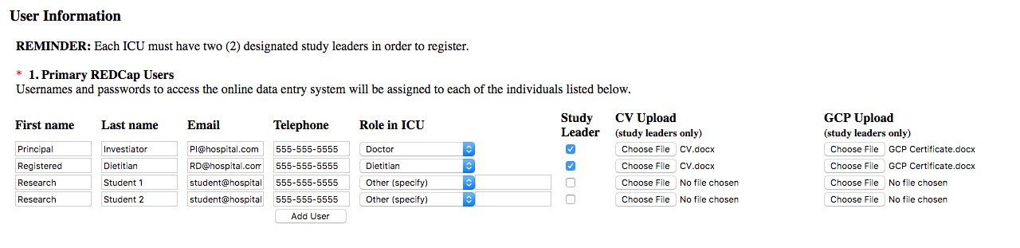
- Please complete all of the fields for each local study team member.

Each registered ICU should have two (2) designated study leaders. One study leader will be an ICU physician, and the other can be either an ICU dietitian or ICU research coordinator.
  - The “Study Leader” checkbox should be selected for these individuals.
  - In order to confirm your site is knowledgeable about critical care nutrition, each study leader must upload their CV and Good Clinical Practice (GCP), or equivalent, training certificate.

Add a new row to the table by selecting the “ADD USER” button.

PLEASE NOTE: The email address entered for each person will be linked to the electronic data capture system (i.e. REDCap) for the study. This is the system that will allow you to randomize patients and enter data. As such, be sure you are using an email address where you can receive password resets and system emails.

Ethics Clearance
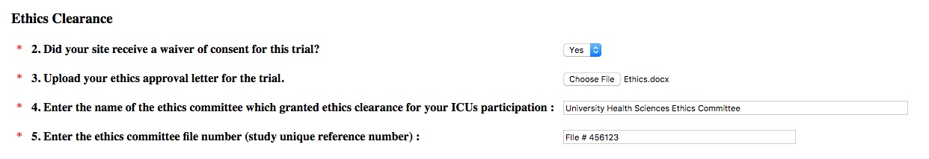
- Indicate either “Yes” or “No” to whether your site received a waiver of consent for this trial.

- A copy of your local site ethics clearance (approval) letter is a requirement for inclusion in this collaborative. Please upload your ethics clearance (approval) letter.

- Enter the name of the ethics committee which granted ethics clearance for your ICUs participation.

- Enter the ethics committee file number (study unique reference number).

Hospital Information
- Specify your hospital’s full name, without abbreviations, as you wish for it to appear on your Site Report.

- Select the correct time zone for your region from the list provided.
- Enter the type of hospital, either “Teaching” or “Non-Teaching”. A teaching hospital is a hospital that provides training to medical students and residents. If your hospital only has occasional medical students/residents, select non-teaching hospital.
- Specify the city, province/state and country your hospital is located in.
- Specify the province/state your hospital is located in.

- Specify the country your hospital is located in using the dropdown menu.

- Enter the total number of beds in your hospital.

ICU Information
- Indicate whether or not your hospital has multiple ICUs. If your site has multiple ICUs, and you wish for more than one to join the collaborative, each ICU must be registered separately.

- Specify your ICU’s name as you wish for it to appear on your Site Report.

- Specify the type of ICU (ICU structure), either “Open”, “Closed”, or “Other, specify”. Open ICUs are sites where patients are under the care of an attending physician (e.g. internist, family physician, surgeon) with intensivists (i.e. physician with training in critical care) consulted as necessary. Patients in closed ICUs are under the care of an intensivist or care is shared between the intensivist and another attending physician.

- Indicate all case types applicable to this ICU.

- Indicate whether or not your ICU has a designated Medical Director.

- Is your ICU specifically a burn unit?

- Indicate how many beds your ICU contains.

- Specify whether you have a dietitian working in the ICU.
If yes, please specify the amount of full time equivalent (FTE). This is a measure of the amount of time the dietitian(s) is/are dedicated to the ICU relative to a full time position. Eg: A full-time equivalent (FTE) of 1.0 means that one dietitian works in the ICU full time (i.e. 5 full days per week). A FTE of 0.5 means that one dietitian is in the ICU half time, or two and a half days a week. A FTE of 1.0 could also mean that two dietitians each work half time (0.5 FTE each) in the ICU.

- Indicate whether you use a bedside feeding protocol/algorithm that allows the nurse to advance or withhold tube feedings. Enteral feeding protocols are defined as: tools designed to enable the bedside nurse to initiate, and/or monitor, and/or modify the administration of EN to individual patients. Implementation of such protocols includes, but is not limited to, the use of pre-printed orders that are signed by a physician when a patient is admitted to the ICU and a bedside algorithm that provides instructions to the bedside nurse on the management of EN. We are not referring to a policy document, but bedside tools.
If “Yes”, indicate which components you are implementing in your ICU (check all that apply).
If “Yes”, what type of formula do you use as your initial or starting formula as part of your feeding protocol: semi-elemental feeding formula, or polymeric feeding formula, or other type (specify).
- Do you use a gastric residual volume threshold to adjust feeds?
If “yes”, indicate the gastric residual volume threshold in milliliters (mL).
- Do you use a protocol or algorithm to monitor blood sugar control or the administration of insulin?
If “yes”, specify whether you use a ‘target range’ or ‘target value’ to monitor glucose.
If you use a ‘target range’, enter the corresponding values, including units (mmol/L or mg/dL).
If you use a ‘target value’, enter the corresponding value, including units (mmol/L or mg/dL).

Confirmation
In order to participate in this trial, sites must confirm that they understand and agree to all 5 of the criteria listed.

Signoff
Checking this box indicates you:
- You have had the opportunity to read information about the EFFORT Trial and understand the purpose of this international project;
- The data submitted by your site via the electronic data collection system (REDCap) allows us to disseminate and publish information and make it available for the purpose of scholarship:
  - We will compute site reports comparing statistics across all participating sites;
  - Only aggregated data will be shared. Individual patient information such as demographics and/or clinical information will NEVER be shared;
  - You are allowing us to give your site credit, when appropriate, such as on our website, in journal publications and in press releases.
Select the ‘SUBMIT REGISTRATION FORM’ button to send this application to the coordinating centre for review and approval.

Submission Confirmation Email
After you use the ‘SUBMIT REGISTRATION FORM’ to complete your registration form. You will see the following screen.

Registration Approval Emails
AFTER the coordinating centre has reviewed and approved your site to join, you will receive 2 emails:
- Registration Confirmation & Welcome Message
Note: the coordinating centre will respond to registration requests as quickly as possible. Please allow for 72h for a response before you contact them about the status of your registration.
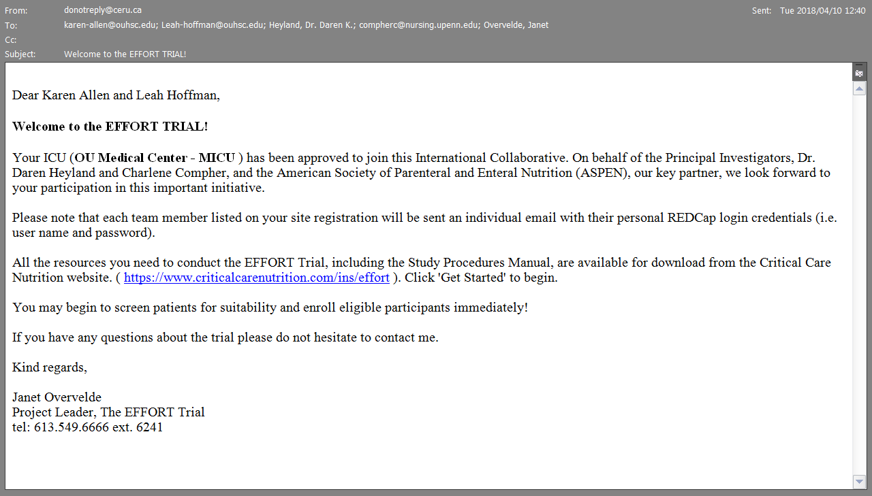
(<<ICU Name>>)
<<Leader 1>> and <<Leader 2>>,

- REDCap login credentials message (user id and password)

APPENDIX - Site Registration Form

Site and Study Team Member Qualifications
- Primary REDCap Users:
Usernames and passwords to access the online data entry system will be assigned to each of the individuals listed below.
First name | Last name | Email | Phone | *Role in ICU | Study Leader  (Y/N)

*Role in ICU options: Dietitian, Registered Nurse, Research Coordinator, Doctor, Pharmacist, Other (specify).
CVs - Upload the CVs for the two study leaders indicated above.

GCP Training Certificates - Upload the GCP training certificates for the two study leaders indicated above.

Ethics Clearance
Hospital Information
- Did your site receive a waiver of consent for this trial?
Yes
No

- A copy of your local site ethics clearance (approval) letter is a requirement for inclusion in this collaborative. Please upload your ethics clearance (approval) letter.

- Name of Ethics Committee: __________________________________________

- Ethics Reference Number (study unique ID): _______________________

Hospital Information
- Hospital Name: ________________________________
- Hospital time zone: ___________________________________
- Hospital Type: Teaching Non-Teaching
- City: _________________ 9. Province/State: _____________ 10. Country: ______________
- Size of Hospital (Number of Beds): __________________

ICU information
- Does your hospital have multiple ICU? Yes No
- ICU Name: _____________________________________________
- ICU Type:
Open: Attending physician remain in charge, ICU physician consults.
Closed: Care transferred or shared with ICU physician
Other, please specify: ____________________________________________
- Case Types (select all that apply):
Medical Pediatrics Cardiac Surgery
Surgical Neurological Burns
Trauma Neurosurgical Other, please specify: ______________________
- Is there a designated ICU Medical Director?
Yes
No

- Number of beds in ICU: ___________
- Do you have a Dietitian working in the ICU?
Yes If yes: Amount of full time equivalent (FTE) dietitian: ___________
No

- Do you use a bedside feeding protocol/algorithm that allows the nurse to advance or withhold tube feedings as specified by the protocol/algorithm?
Yes – We have a feeding protocol
No – No systematic or standardized approach to feeding at the bedside

If yes to “Feeding Protocol”, indicate which components you are implementing in your ICU (check all that apply):
 An initial feeding strategy that includes the use of volume based feeding
 Prophylactic use of motility agents starting with start of enteral nutrition
 Protein supplements starting with start of enteral nutrition
What type of formula do you use as your initial or starting formula as part of your feeding protocol (select only one)?
 Semi-elemental feeding formula
 Polymeric feeding formula
 Other type of formula , Please Specify: ______________________________

- Do you use a gastric residual volume threshold to adjust feeds?
Yes If yes, what volume threshold do you use? ___________ millilitres (ml)
No

- Do you use a protocol to monitor blood sugar control or the administration of insulin?
Yes If yes: What range do you target? -OR- What value do you target?
No Lower:_______ mmol/L mg/dL Target: _______ mmol/L mg/dL
Upper:_______ mmol/L mg/dL

Confirmation
In order to participant in this trial, sites must confirm that:
- They have read the protocol and associated training materials on the CCN website and have adequate resources to conduct this trial; AND
- They will abide by the randomization scheme and arm assignment (high vs. low protein prescription) and avoid overfeeding for each randomized patient; AND
- They use a standardized feeding protocol in their ICU for enteral and parenteral nutrition; AND
- Have access to a range of commercial enteral and parenteral feeding products (eg. high protein EN formulas, protein supplements, parenteral nutrition formulations or amino acids) that they will use to achieve protein targets without providing excessive calories; AND
- They are committed to enrolling a minimum of 30 eligible patients within 2-3 years.

Signoff
Checking this box indicates that:
- You have had the opportunity to read information about the EFFORT Trial and understand the purpose of this international project;
- The data submitted by your site via the electronic data collection system (REDCap) allows us to disseminate and publish information and make it available for the purpose of scholarship:
  - We will compute site reports comparing statistics across all participating sites;
  - Only aggregated data will be shared. Individual patient information such as demographics and/or clinical information will NEVER be shared;
  - You are allowing us to give your site credit, when appropriate, such as on our website, in journal publications and in press releases.

___________________________________End of Form________________________________________

